**Update Your Python with Latest Version**

**STEP 1:**

Visit this Link: <https://www.python.org/>

Download it as per your System requirements.

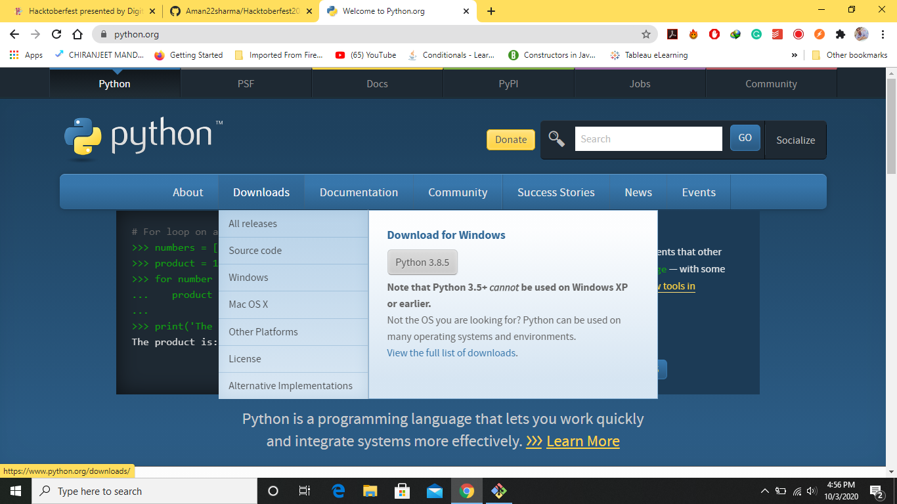

**STEP 2:**

Open file and select Modify

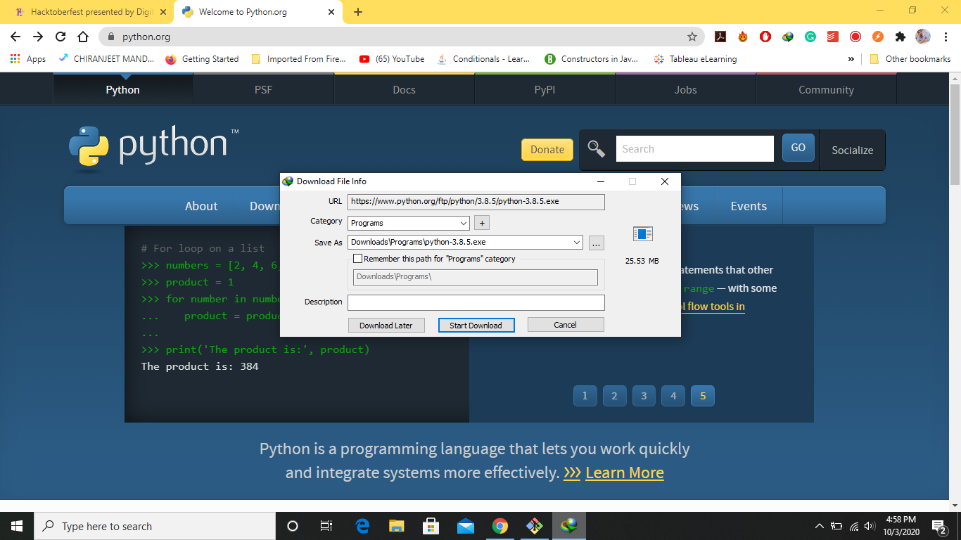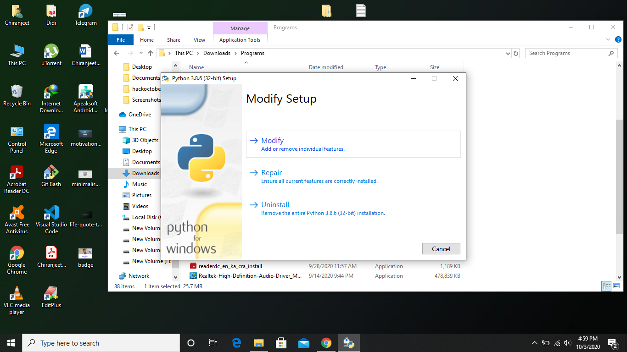

**STEP 3:**

Checked all the options

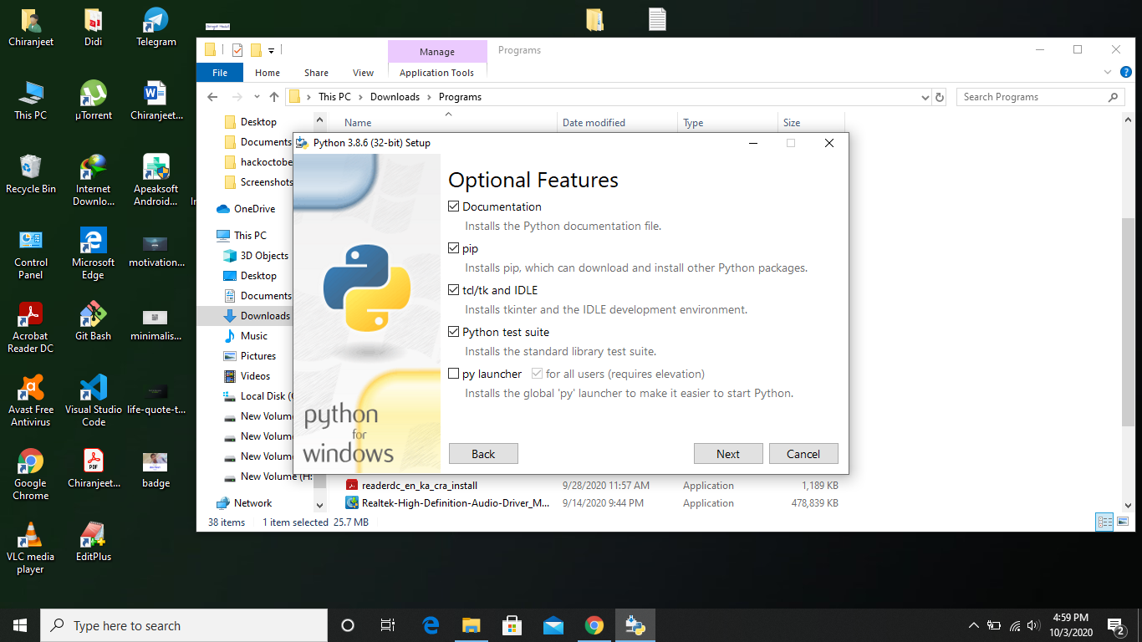

**STEP 4:**

Click NEXT> INSTALL>DONE

